Constructor Chaining In Java with Examples

Prerequisite – [Constructors in Java](https://www.geeksforgeeks.org/constructor-in-java/)  
Constructor chaining is the process of calling one constructor from another constructor with respect to current object.  
Constructor chaining can be done in two ways:

* **Within same class**: It can be done using **this()** keyword for constructors in same class
* **From base class:**by using **super()** keyword to call constructor from the base class.

Constructor chaining occurs through **inheritance**. A sub class constructor’s task is to call super class’s constructor first. This ensures that creation of sub class’s object starts with the initialization of the data members of the super class. There could be any numbers of classes in inheritance chain. Every constructor calls up the chain till class at the top is reached.

**Why do we need constructor chaining ?**  
This process is used when we want to perform multiple tasks in a single constructor rather than creating a code for each task in a single constructor we create a separate constructor for each task and make their chain which makes the program more readable.

**Constructor Chaining within same class using this() keyword :**

[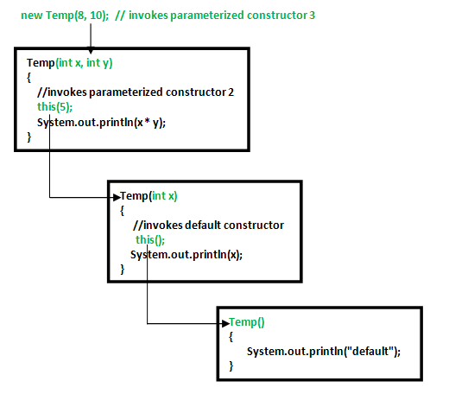](http://cdncontribute.geeksforgeeks.org/wp-content/uploads/Constructor-Chaining-In-Java1.png)

|  |
| --- |
| // Java program to illustrate Constructor Chaining  // within same class Using this() keyword  class Temp  {      // default constructor 1      // default constructor will call another constructor      // using this keyword from same class      Temp()      {          // calls constructor 2          this(5);          System.out.println("The Default constructor");      }        // parameterized constructor 2      Temp(int x)      {          // calls constructor 3          this(5, 15);          System.out.println(x);      }        // parameterized constructor 3      Temp(int x, int y)      {          System.out.println(x * y);      }        public static void main(String args[])      {          // invokes default constructor first          new Temp();      }  } |

Output:

75

5

The Default constructor

**Rules of constructor chaining :**

1. The **this()** expression should always be the first line of the constructor.
2. There should be at-least be one constructor without the this() keyword (constructor 3 in above example).
3. Constructor chaining can be achieved in any order.

**What happens if we change the order of constructors?**

Nothing, Constructor chaining can be achieved in any order

|  |
| --- |
| // Java program to illustrate Constructor Chaining  // within same class Using this() keyword  // and changing order of constructors  class Temp  {      // default constructor 1      Temp()      {          System.out.println("default");      }        // parameterized constructor 2      Temp(int x)      {          // invokes default constructor          this();          System.out.println(x);      }        // parameterized constructor 3      Temp(int x, int y)      {          // invokes parameterized constructor 2          this(5);          System.out.println(x * y);      }        public static void main(String args[])      {          // invokes parameterized constructor 3          new Temp(8, 10);      }  } |

Output:

default

5

80

NOTE: In example 1, default constructor is invoked at the end, but in example 2 default constructor is invoked at first. Hence, order in constructor chaining is not important.

**Constructor Chaining to other class using super() keyword :**

|  |
| --- |
| // Java program to illustrate Constructor Chaining to  // other class using super() keyword  class Base  {      String name;        // constructor 1      Base()      {          this("");          System.out.println("No-argument constructor of" +                                             " base class");      }        // constructor 2      Base(String name)      {          this.name = name;          System.out.println("Calling parameterized constructor"                                                + " of base");      }  }    class Derived extends Base  {      // constructor 3      Derived()      {          System.out.println("No-argument constructor " +                             "of derived");      }        // parameterized constructor 4      Derived(String name)      {          // invokes base class constructor 2          super(name);          System.out.println("Calling parameterized " +                             "constructor of derived");      }        public static void main(String args[])      {          // calls parameterized constructor 4          Derived obj = new Derived("test");            // Calls No-argument constructor          // Derived obj = new Derived();      }  } |

Output:

Calling parameterized constructor of base

Calling parameterized constructor of derived

Note : Similar to constructor chaining in same class, **super()** should be the first line of the constructor as super class’s constructor are invoked before the sub class’s constructor.